- COURSE OBJECTIVES (commonly referred as “student learning outcomes- SLOs”)
- Number should be feasible to measure (recommended: 4-6)
- Measurable SLOs (e.g., Bloom Taxonomy’s as a reference: click here for a handout)
SLOs are SMART (specific, measurable, actionable, realistic & time based)

- COURSE GOALS vs. COURSE OBJECTIVES
Comparison | Course Goal | Course Objective
Meaning | A goal is a long-term purpose which a person strives to achieve. | Objectives are the achievements which can be attained only if the attempts are made in a particular direction.
What is it? | End result | Means to an end
Basis | Ideas | Facts
Time frame | Long term | Medium term to short term
Measurement | Comparatively difficult | Easy
Action | Generic | Specific
From UNM Office of Assessment workshop on Strategic Planning (10/13/2021)

- PROCESS FOR MAPPING A COURSE
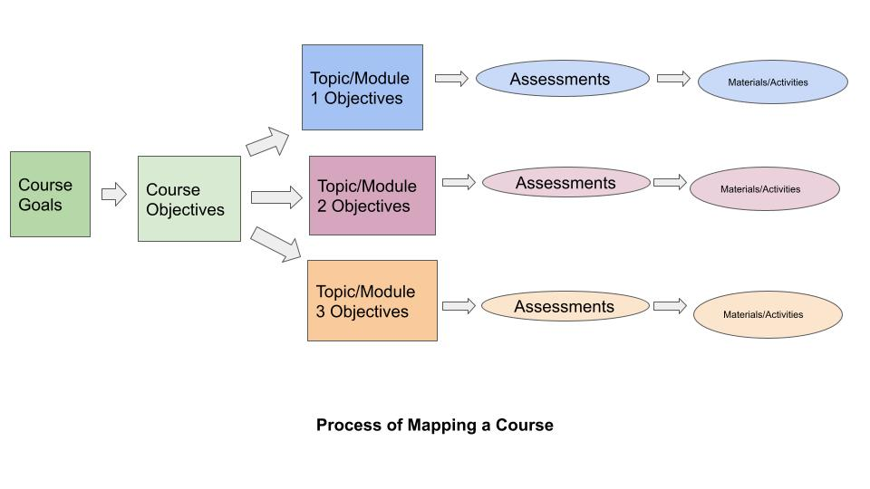
From UNM- Mary Willms Wohlwend

For examples and best practices of Goals and SLOs, visit UNM Office of Assessment website
(check Best Practices section halfway down).

For differences between course objectives and topic/module/week objectives (Teaching Online primarily), click here for a tutorial.

